Multiple-choice section – choose the correct answer

Question 1 [6.1]

Which containers are taller than the saucepan and have a larger capacity than the cup?

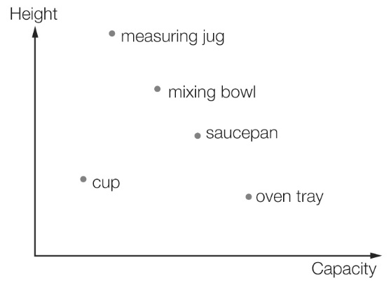

A measuring jug and mixing bowl

B mixing bowl and oven tray

C saucepan and measuring jug

D cup and saucepan

Question 2 [6.1]

The graph shows the travelling pattern of a family on a day’s journey. The family had a number of rests during their journey. The fraction of the time that the family spent resting is closest to:

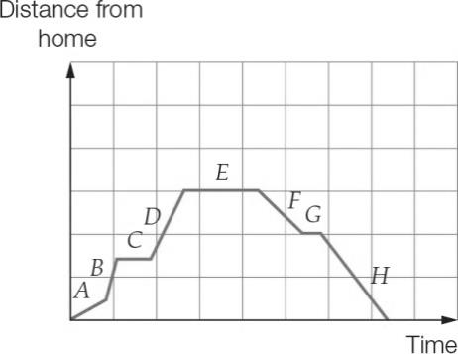

A half of the journey time

B one-quarter of the journey time

C three-quarters of the journey time

D four-tenths of the journey time

Question 3 [6.2]

An ordered pair representing a point that is on the line 2*y* + 1 = *x* is:

A (0, -1) B (-1, 1) C (-1, -1) D (1, 1)

Question 4 [6.2]

Which table does not match the graph?

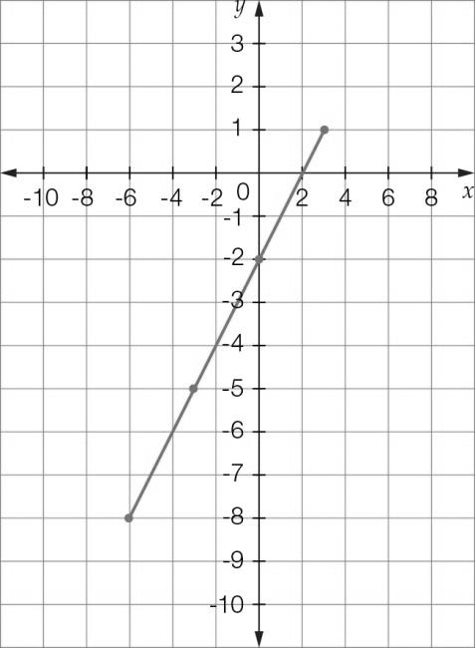

A

|  |  |  |  |  |
| --- | --- | --- | --- | --- |
| *x* | -8 | -5 | -2 | 1 |
| *y* | -10 | -7 | -4 | -1 |

B

|  |  |  |  |  |
| --- | --- | --- | --- | --- |
| *x* | -6 | -3 | 0 | 1 |
| *y* | -8 | -5 | -2 | -1 |

C

|  |  |  |  |  |
| --- | --- | --- | --- | --- |
| *x* | 1 | 2 | 5 | 8 |
| *y* | 2 | 4 | 3 | 6 |

D

|  |  |  |  |  |
| --- | --- | --- | --- | --- |
| *x* | -4 | 0 | 3 | 7 |
| *y* | -6 | -2 | 1 | 5 |

Question 5 [6.2]

The coordinates of a point which lies on the graph of *y* = 2*x* – 3 are:

A (1, 5) B (, 0) C (0, ) D (, 6)

Question 6 [6.2]

What are the coordinates of the *x*-intercept and the *y*-intercept of this graph?

|  |  |
| --- | --- |
| C:\Users\ubuluay\Desktop\2nd ed\PM2e-8-ch-tests-exams-RWs\_SUPPLIED_V1_CORREX_230916\PM2e_08_EB_06_AT_06.jpg | A (0,1) and (0,3)  B (1,1) and (0,3)  C (1.5,0) and (0,3)  D (1.5,0) and (0,-3) |

Question 7 [6.3]

The rule for the set of points (2, 8), (3, 11), (4, 14) is:

A *y* = 4*x* B *y* = 2*x* C *y* = 3*x* + 2 D *x* = 2*y*

Question 8 [6.2]

Which of the following points is on both the line with the equation and the line with   
the equation *x* = *y* + 11?

A (1, -4) B (2, -6) C (3, -8) D (4, -13)

Question 9 [6.2]

The *x*-intercept of the line with the equation  is:

A (,0) B (,0) C (,0) D (,0)

Question 10 [6.2]

The *y*-intercept of the line with equation  is:

A 3 B 1 C -1 D 

Question 11 [6.2]

The line given by the equation *y* = 0.01*x* – 5:

A has a gradient of zero B is nearly flat

C is very steep D is not very steep

Question 12 [6.4]

The cost $*C* of renting a car is given by the formula *C* = 5*d* + 4, where *d* is the number of days.  
If Frank paid $119 for the car, how many days did he rent the car for?

A 20 days B 10 days

C 23 days D 30 days

Multiple-choice results: \_\_\_ /12

Short answer section

Question 13 7 marks [6.2]

Use words from the list below to complete the following sentences.

*left straight line slope y-intercept gradient slope zero gradient*

*positive linear origin y-intercept x-axis Cartesian negative*

(a) Lines with a \_\_\_\_\_\_\_\_\_\_\_\_\_\_\_\_\_ gradient \_\_\_\_\_\_\_\_\_\_\_\_\_\_ up to the right and lines with a   
\_\_\_\_\_\_\_\_\_\_\_\_ gradient \_\_\_\_\_\_\_\_\_\_\_\_\_ up to the \_\_\_\_\_\_\_\_\_\_\_\_\_\_.

(b) The \_\_\_\_\_\_\_\_\_\_\_\_\_\_ of a line is a measure of its steepness.

(c) The *x*-intercept is where a line crosses the \_\_\_\_\_\_\_\_\_ and the \_\_\_\_\_\_\_\_\_\_\_\_\_\_ is where a line crosses the *y*-axis.

(d) The point (0, 0) is the \_\_\_\_\_\_\_\_\_\_\_\_\_\_\_ of the \_\_\_\_\_\_\_\_\_\_\_\_\_\_\_ plane.

(e) When points on a graph make a \_\_\_\_\_\_\_\_\_\_\_\_\_\_\_\_\_\_\_\_\_\_then the relationship between the variables is \_\_\_\_\_\_\_\_\_\_\_\_\_\_\_.

(f) When lines are flat they have a gradient of \_\_\_\_\_\_\_\_\_\_\_\_.

(g) In the equation *y* = *mx* + *c*,  is the \_\_\_\_\_\_\_\_\_\_\_\_\_\_\_\_\_\_\_\_ of the line and  is the \_\_\_\_\_\_\_\_\_\_\_\_\_\_\_\_\_ of the line.

Question 14 3 marks [6.2]

Draw three lines on a set of axes and use them to show the difference between lines with a positive, negative and zero gradient.

Question 15 2 marks [6.2]

State the equation of the horizontal line and the equation of the vertical line passing through the point .

Question 16 4 marks [6.1]

Use the graph below to answer the following questions.

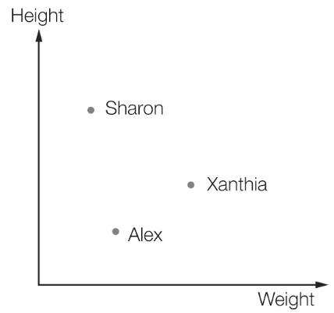

(a) What are the two variables shown in the graph?

(b) Approximately how much taller is Sharon than Alex?

(c) Approximately how much heavier is Xanthia than Alex?

(d) Compare the height and weight of each of the three people.

Question 17 3 marks [6.1]

The Miller family is travelling by car to their holiday destination. The following graph shows the distance the Millers are from home.

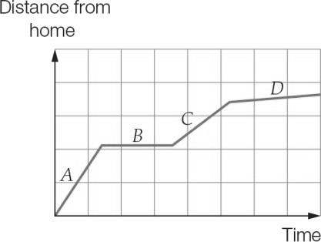

(a) In which section of the graph (*A, B, C* or *D*) are they travelling the fastest?

(b) In which section are they not moving?

(c) Approximately how much faster did they travel in section *A* compared to section *C*?

Question 18 3 marks [6.2]

Complete the table of values for the rule .

|  |  |  |  |  |  |  |  |
| --- | --- | --- | --- | --- | --- | --- | --- |
| *x* | -3 | -2 | -1 | 0 | 1 | 2 | 3 |
| *y* |  |  |  |  |  |  |  |

Question 19 4 marks [6.3]

Find the equation which describes the following relationship by creating a table of values  
from *x* = -3 to *x* = 3.

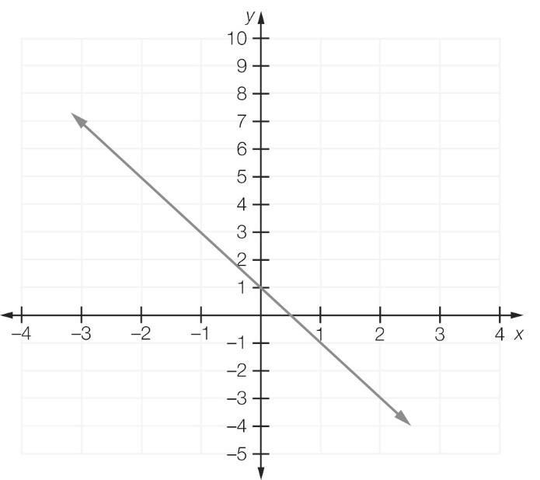

|  |  |  |  |  |  |  |  |
| --- | --- | --- | --- | --- | --- | --- | --- |
|  |  |  |  |  |  |  |  |
|  |  |  |  |  |  |  |  |

Question 20 6 marks [6.3]

Plot the following points on the Cartesian plane below. Join the points with a straight line then find the gradient, *y*-intercept and the rule that relates *x* and *y*.

(a) (2, -4), (0, 1) (b) (4, 5), (-2, 2)

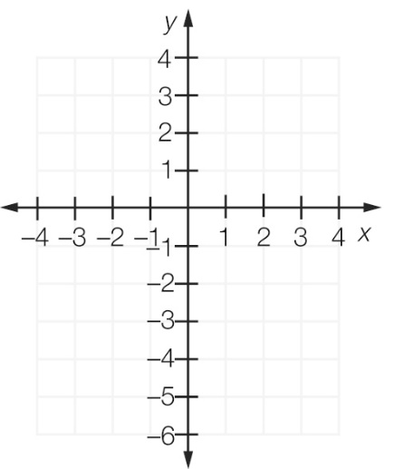

Question 21 4 marks [6.3]

Write the equation of each of the following lines.

(a)

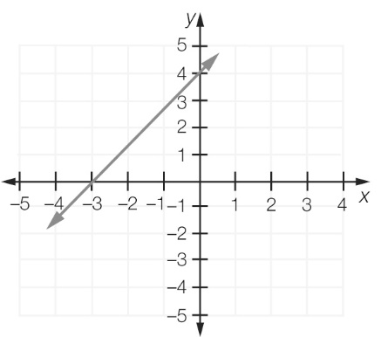

(b)

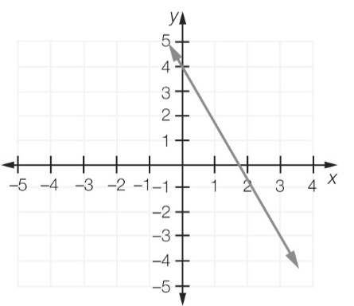

Question 22 2 marks [6.2]

Find the *x*-intercept and *y*-intercept for the line .

Question 23 3 marks [6.2]

Graph the lines  on the same set of axes. Use the graphs to find the point of intersection.

Question 24 1 mark [6.3]

What is the equation of the line that is parallel to the *y*-axis and that passes through the point ?

Short answer results: \_\_\_ / 42

Extended answer section

Question 25 5 marks [6.1]

A family went for a long drive in a car. At the start of the trip the petrol tank contained 60 L of petrol and was full. After driving 500 km they bought 12 L of petrol and this made the tank half full. After another 400 km they bought 58 L and this filled the tank.

(a) Complete the table of values showing how much petrol was in the tank at different distances on the trip.

|  |  |  |  |  |  |
| --- | --- | --- | --- | --- | --- |
| Distance from start (km) | 0 | 500 | 500 | 900 | 900 |
| Petrol in tank (L) |  |  |  |  |  |

(b) Use your table in (a) to plot a graph of the amount of petrol in the tank.

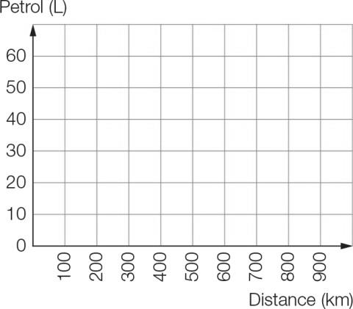

(c) Compare the rate that petrol is being used for the two parts of the trip (in litres per 100 km).

(d) How is the answer to (c) shown on the graph?

Question 26 5 marks [6.3]

The following shapes have been made with matchsticks.

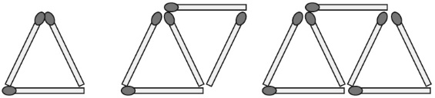

(a) Find the pattern or rule, in terms of *t* (number of triangles) and *m* (number of matches).

(b) Complete the table of values.

|  |  |
| --- | --- |
| Number of triangles  (*t*) | Number of matches  (*m*) |
| 1 |  |
| 3 |  |
| 5 |  |
| 7 |  |
| 9 |  |

(c) Plot each set of values then join the points with a straight line. Find the number of matches needed to build 10 triangles.

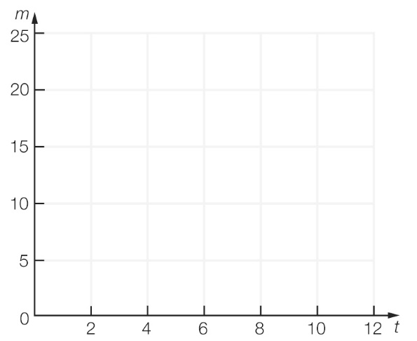

Question 27 4 marks [6.3]

A car repair company charges a $40 fee to attend for the repair and then $24.50 per hour for the time spent on the repair.

(a) Find a rule for calculating the cost *C* in terms of time spent on repairs *t*.

(b) Draw a linear graph of *C* against *t*.

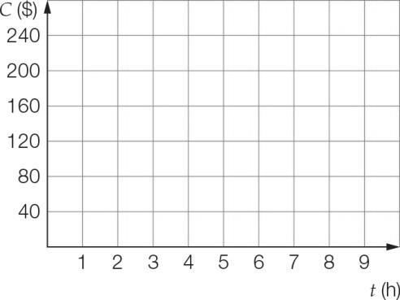

(c) How much will you pay if your car is repaired in 3.5 hours?

Question 28 4 marks [6.4]

The toll on the recently completed Radnor bridge is charged as follows:

Each vehicle is charged $3.25 and each occupant in a vehicle is charged $0.80.

(a) What is the toll for a vehicle with one occupant?

(b) What is the rule for the toll *T* in terms of the number of occupants *p*?

(c) What is the toll for a vehicle carrying 62 occupants?

Question 29 5 marks [6.4]

When you convert measurements in feet into measurements in metres, 10 feet is approximately the same as 3 metres.

(a) Use the statement above to complete this table of values of feet and metres.

|  |  |  |  |  |  |  |  |
| --- | --- | --- | --- | --- | --- | --- | --- |
| Number of feet | 0 | 100 | 200 | 300 | 400 | 500 | 10 000 |
| Number of metres |  |  |  |  |  |  |  |

(b) Using *f* for the number of feet and *m* for the number of metres, write a rule showing the relationship.

(c) Draw a graph of this relationship for numbers of feet up to 10.

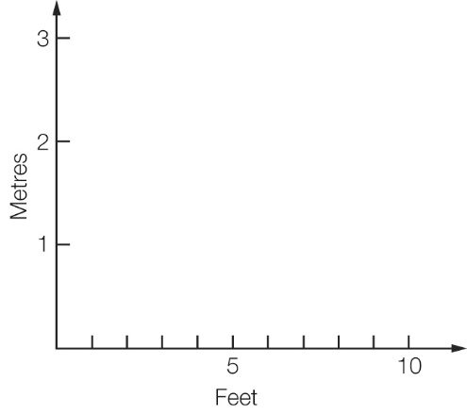

(d) Use an appropriate method to convert  feet to metres.

(e) How many feet are there in metres?

Extended answer results: \_\_\_ / 23

TOTAL test results: \_\_\_ / 77